PROJECT

# [VOTING MACHINE with Arduino](https://circuitdigest.com/microcontroller-projects/7-segment-display-interfacing-with-arduino)

In this project we have used four push buttons for four different candidates. We can increase the number of candidate but for better understanding we have limited it to four. When any voter press any of four button then respecting voting value will increment by one each time. After whole voting we will press result button to see the results. As the "result" button is pressed, arduino calculates the total votes of each candidate and show it on LCD display.

Circuit and Working

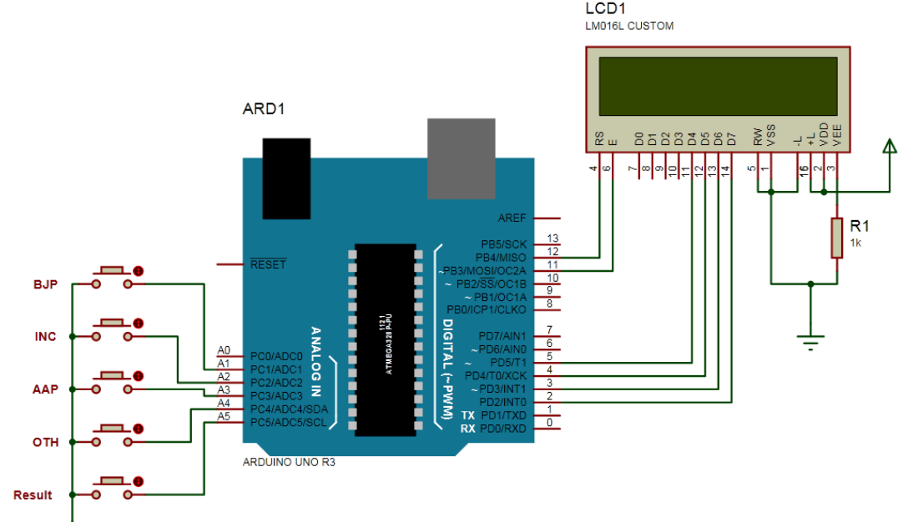

PIN CONNECTIONS

Control pin RS, RW and En are directly connected to arduino pin 12, GND and 11. And data pin D4-D7 is connected to pins 5, 4, 3 and 2 of arduino.

The five push buttons are directly connected with pin 15-19(A1-A5) of Arduino with respect to ground.

WORKING

Circuit of this project is quite easy which contains Arduino, push buttons and LCD. Arduino controls the complete processes like reading button, incrementing vote value, generating result and sending vote and result to LCD. Here we have added five buttons in which first button is for BJP, second for INC, third is for AAP, forth is for OTH means others and last button is used for calculating or displaying results.

CODE

#include<LiquidCrystal.h>  
LiquidCrystal lcd(12, 11, 5, 4, 3, 2);

#define sw1 15  
#define sw2 16  
#define sw3 17  
#define sw4 18  
#define sw5 19  
int vote1=0;  
int vote2=0;  
int vote3=0;  
int vote4=0;  
void setup()  
{  
  pinMode(sw1, INPUT);  
  pinMode(sw2,INPUT);  
  pinMode(sw3,INPUT);  
  pinMode(sw4,INPUT);  
  pinMode(sw5,INPUT);  
  lcd.begin(16, 2);  
  lcd.print("Voting Machine");  
  lcd.setCursor(0,1);  
  lcd.print("Circuit Digest");  
  delay(3000);  
  digitalWrite(sw1, HIGH);  
  digitalWrite(sw2, HIGH);  
  digitalWrite(sw3, HIGH);  
  digitalWrite(sw4, HIGH);  
  digitalWrite(sw5, HIGH);  
  lcd.clear();  
  lcd.setCursor(0,0);  
  lcd.print("BJP");  
  lcd.setCursor(4,0);  
  lcd.print("INC");  
  lcd.setCursor(8,0);  
  lcd.print("AAP");  
  lcd.setCursor(12,0);  
  lcd.print("OTH");  
}  
void loop()  
{  
  lcd.setCursor(0,0);  
  lcd.print("BJP");  
  lcd.setCursor(1,1);  
  lcd.print(vote1);  
  lcd.setCursor(4,0);  
  lcd.print("INC");  
  lcd.setCursor(5,1);  
  lcd.print(vote2);  
  lcd.setCursor(8,0);  
  lcd.print("AAP");  
   lcd.setCursor(9,1);  
  lcd.print(vote3);  
  lcd.setCursor(12,0);  
  lcd.print("OTH");   
  lcd.setCursor(13,1);  
  lcd.print(vote4);  
  if(digitalRead(sw1)==0)  
    vote1++;  
    while(digitalRead(sw1)==0);  
  if(digitalRead(sw2)==0)  
    vote2++;  
    while(digitalRead(sw2)==0);  
  if(digitalRead(sw3)==0)  
    vote3++;  
    while(digitalRead(sw3)==0);  
   if(digitalRead(sw4)==0)  
    vote4++;  
    while(digitalRead(sw4)==0);  
   if(digitalRead(sw5)==0)  
   {  
     int vote=vote1+vote2+vote3+vote4;  
     if(vote)  
     {  
      if((vote1 > vote2 && vote1 > vote3 && vote1 > vote4))  
      {  
       lcd.clear();  
       lcd.print("BJP Wins");  
       delay(2000);  
       lcd.clear();  
      }  
      else if((vote2 > vote1 && vote2 > vote3 && vote2 > vote4))  
      {  
       lcd.clear();  
       lcd.print("INC Wins");  
       delay(2000);  
       lcd.clear();  
      }  
      else if((vote3 > vote1 && vote3 > vote2 && vote3 > vote4))  
      {  
       lcd.clear();  
       lcd.print("AAP Wins");  
       delay(2000);  
       lcd.clear();  
      }  
     else if(vote4 > vote1 && vote4 > vote2 && vote4 > vote3)  
     {  
       lcd.setCursor(0,0);  
       lcd.clear();  
       lcd.print("OTH Wins");  
       delay(2000);  
       lcd.clear();  
     }  
       
      else if(vote4 > vote1 && vote4 > vote2 && vote4 > vote3)  
     {  
       lcd.setCursor(0,0);  
       lcd.clear();  
       lcd.print("OTH Wins");  
       delay(2000);  
       lcd.clear();  
     }  
       
     else  
     {  
       lcd.clear();  
       lcd.print("   Tie Up Or   ");  
       lcd.setCursor(0,1);  
       lcd.print("   No Result   ");  
       delay(1000);  
       lcd.clear();  
     }  
       
    }        
     else   
     {  
       lcd.clear();  
       lcd.print("No Voting....");  
       delay(1000);  
       lcd.clear();  
     }  
     vote1=0;vote2=0;vote3=0;vote4=0,vote=0;  
     lcd.clear();  
   }  
     
}

